ASSIGNMENT 6: ASSIGNMENT ON JOIN

Create Employees, Departments, and Locations table from hr:

QUERY:

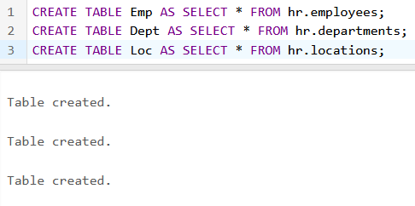

1. Display the employees-id, employee name, dept-id & department name for all the employees

QUERY:

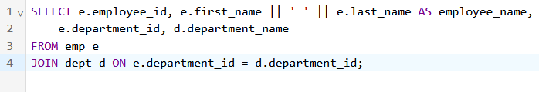

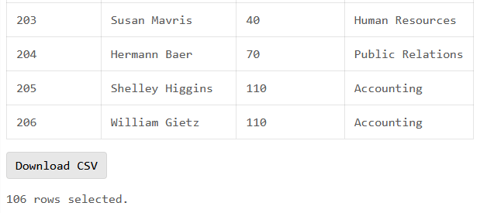

2. Display the employee smith department number & department name.

QUERY:

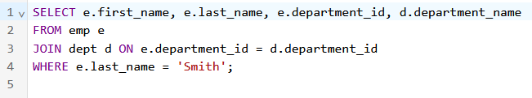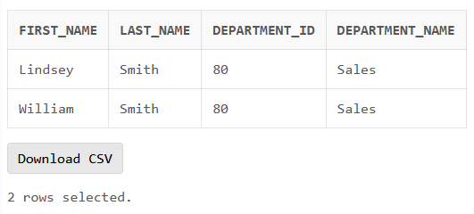

3. Display the employee last name, department name & city for each employee whose salary is greater than 2000.

QUERY:

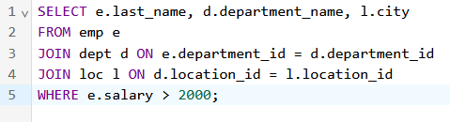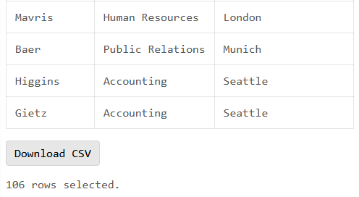

4. Display the employee last name & department name for all employees who have ‘a’ in their last name.

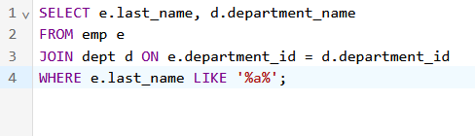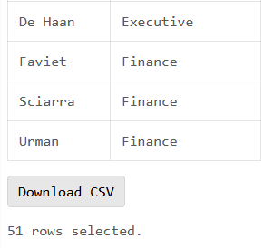

5. Display the employee last name & employee number along with their manager last name & manager number. The output should be in the following sequence (employee-lastname, emp-id, manager-lastname, manager-id).­­­

